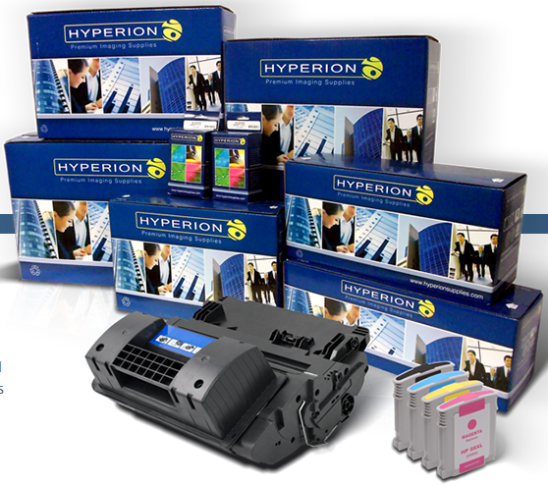



Insert Reseller Logo Here

**ONE-YEAR WARRANTY**

***OEM-Equivalent Performance Guaranteed***

**INDUSTRY-LEADING**

**COST PER PRINT**

**SUPERIOR  
ENGINEERING**

Compatible brands typically  
guarantee product quality, and federal law bans OEMs from voiding warranties for using compatible consumables.

Compatible brands give you more  
options. Use OEM where you need it; switch to Compatible where you don’t.

Compatible and Remanufactured product often use recycled components and less packaging waste than OEM.

Compatible ink and toner offer great cost per print value, saving you big vs. OEM.

**Quality**

**Guaranteed**

**Freedom of  
Choice**

**Sustainable  
Production**

**Cost**

**Savings**

ADVANTAGES

WHY CHOOSE HYPERION

**FOUR REASONS**

**TO SWITCH TO  
COMPATIBLE**

Address

Website

Email

Phone Number